Talal Jawaid

4/5/2019

Professor Doan Nguyen

Assignment #2 Test Cases

Test Case 1: **Movement Controls**

Inputs: arrow keys, to control ship movement

Up arrow increases ship speed

Down arrow decreases ship speed

Left/Right arrows turn the ship.

Expected Output: for ship direction and speed to change accordingly. These values can be observed by pressing m to pull up the game object values.

Preconditions: Playership is spawned into game already.

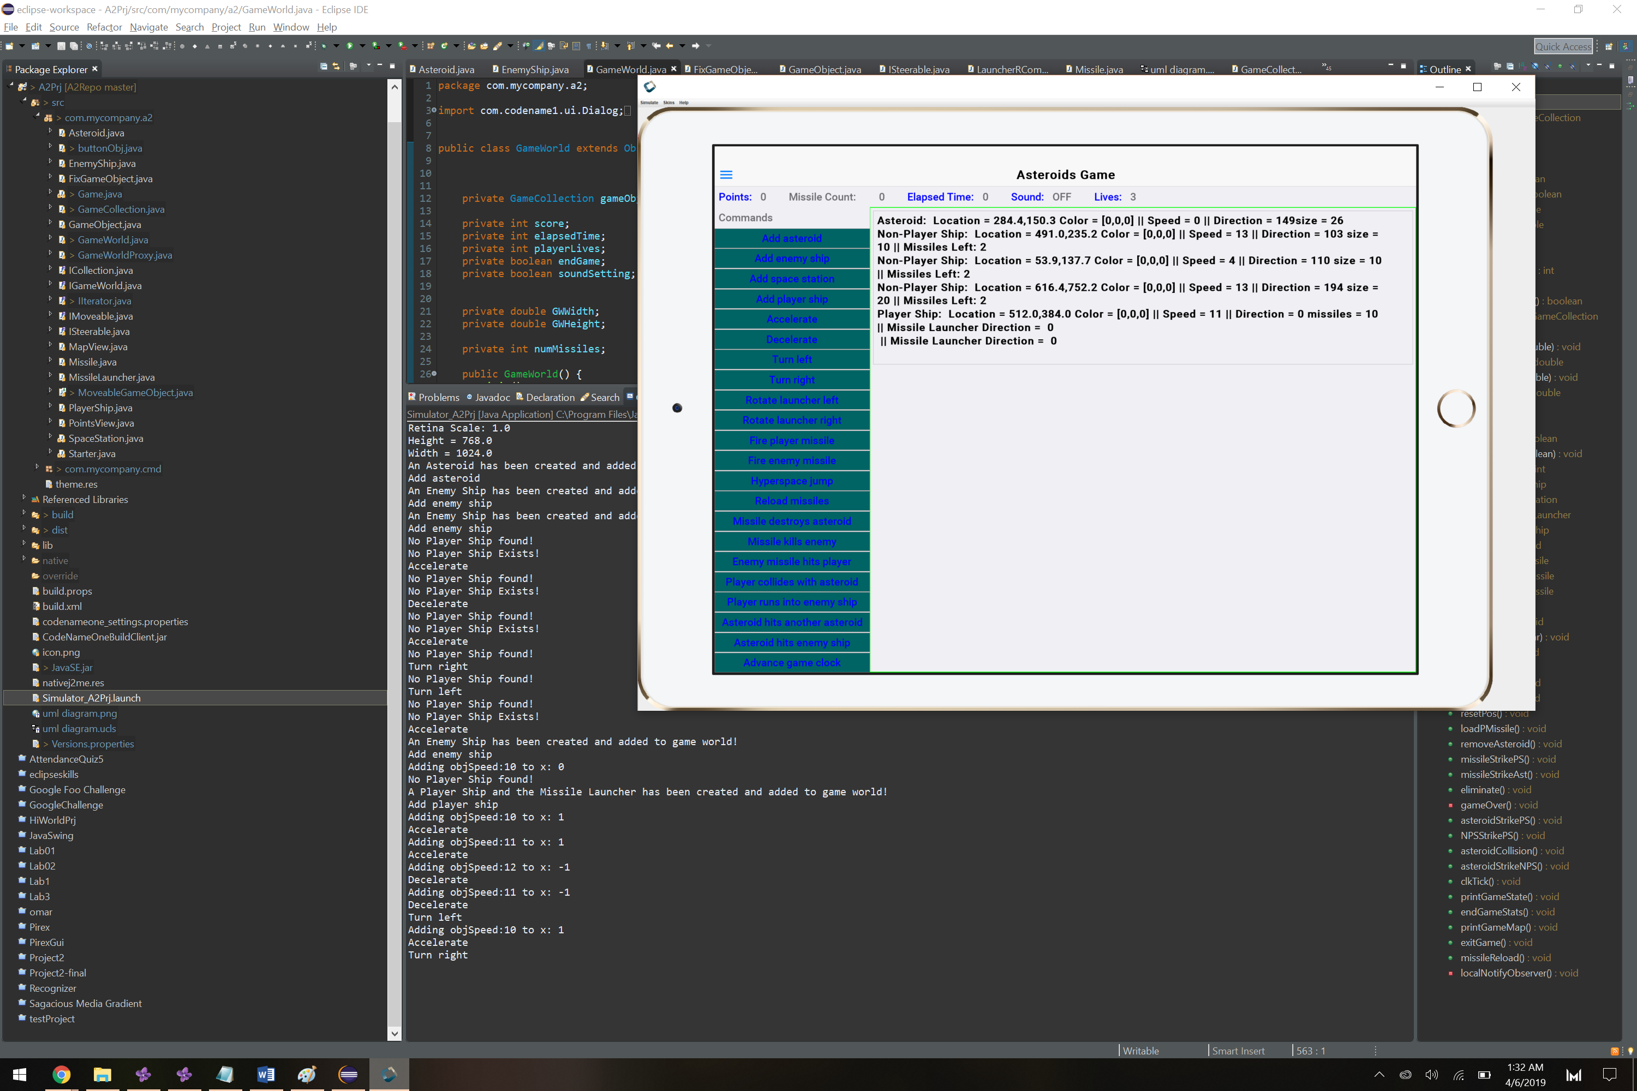

Test Case 2: **About From File Menu**

Inputs: Clicking the About in the file menu.

Expected output: A dialog box should show the user who created the software.

Precondition: Game is on

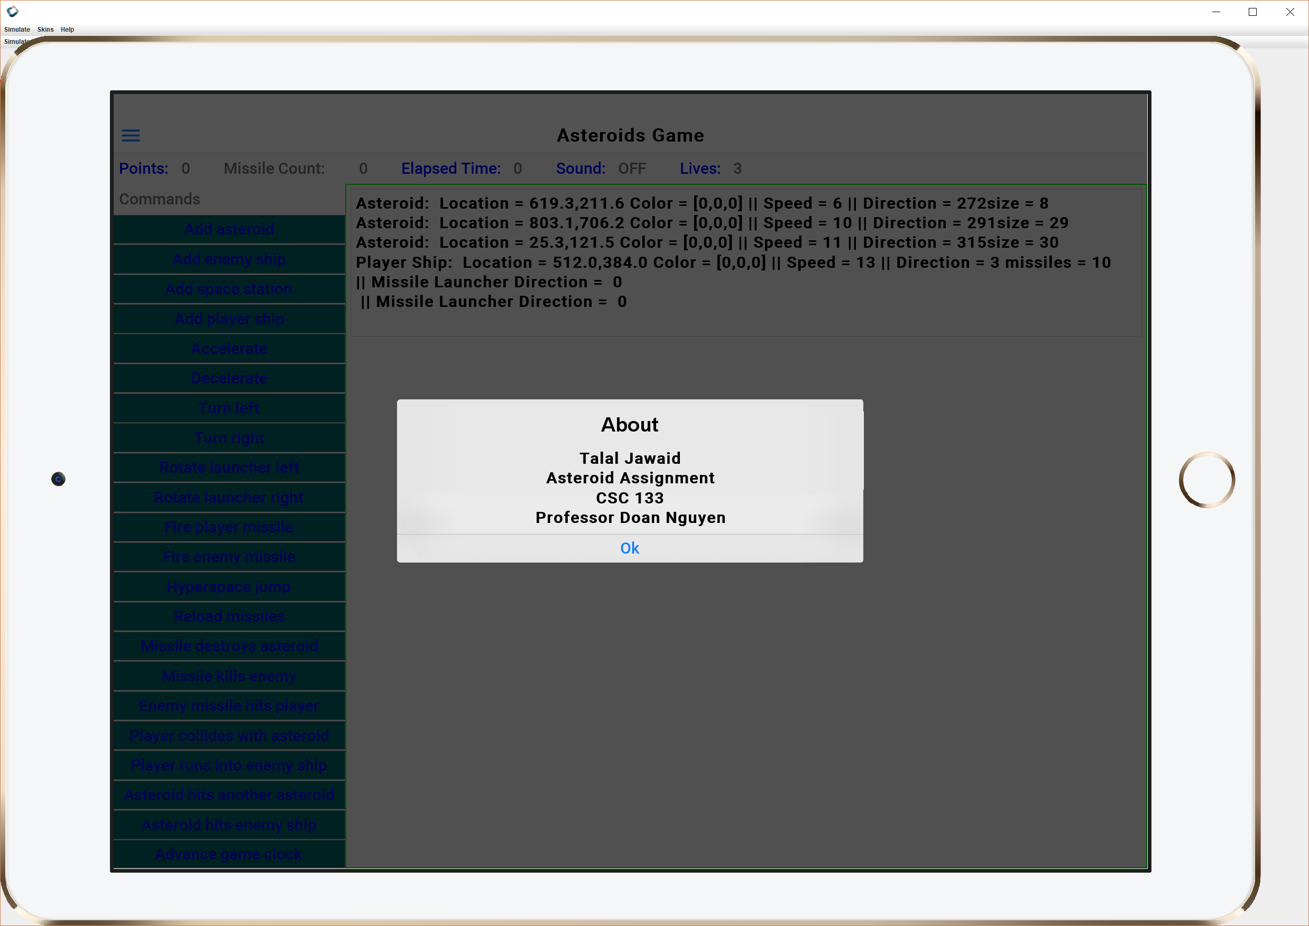

Test Case 3: **Quit Functionality**

Inputs: Hitting the quit button in the drop down menu

Expected Output: The quit button will be pressed, which opens the quit dialog box. The prompt allows the user to quit. Hitting yes should exit the program

Precondition: Game must be running

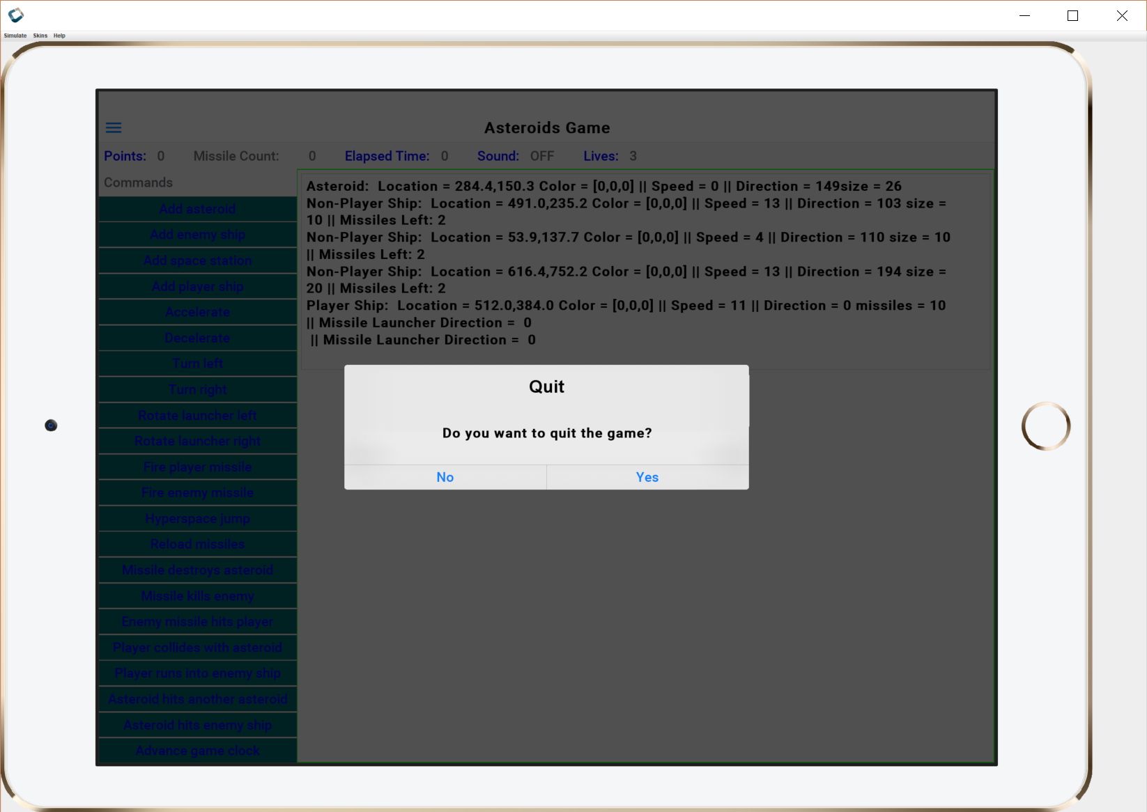.

Test Case 4: **GUI Component Interaction**

Inputs: Click interaction with GUI component

Expected Output: A message printed on system console detailing which GUI component was clicked.

Precondition: GUI Components have to be active on screen, game has to be running.

